
Lin Files - a Starter inc Problem Format written by Roger Pfister
Perhaps one of the following applies to you
You have a collection of hands and would like to easily upload them to BBO,
OR maybe, you would like to turn them into a set of 'problems'.
AND in both cases you do NOT want to delve deeply into lin files.
First - get your hands as lin files
(the videos below are really worth watching):
aaBridge on YouTube docs from the Doc collection
video 002 & 003 Get a BBO hand into aaBridge
video 006 Enter (Type) Hands into aaBridge
(see the suggestions for text editors, etc at the end of this document)
Utilizing a text editor, you can download deals from BBO, and put them all into a single lin file. That is, you would copy and paste all of the text of each lin file into a single file, and save that file with a .lin extension.
DO NOT worry about the format, just copy everything from each lin file to the end of the target .lin file. Adding a couple of blank line at the end of each deal is a good idea, as it makes the file easier to understand.

Using the supplied example file - BBO format
Follow the instructions below using the supplied example lin file that should come along with this document in the ‘doc collection’. It is called …
Lin_Fl.lin
Again Drag and Drop that file on to an open aaBridge window. It will open and display in aaBridge.
When you click Flow or (recommended) use your mouse wheel to step through the file you will see that it contains two deals numbered o3 and o7 both of which show as bumps on the navbar.

Also notice that the first deal (o3) has West as the declarer and that the second deal has North as the declarer.
(FYI – the first deal was a downloaded played hand from BBO -- the second was originally downloaded from a BBO teaching table.)
You are going to save these deals. In the example there are just two, but you could have any number.

BBO format
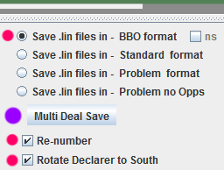
In aaBridge raise the lower (bottom) divider bar to show the additional settings.
Check the three values on the right (red dots) and have only those set.
Click Multi Deal Save (purple dot)
Multi Deal Save works on ALL the deals in a SINGLE lin file.
If your deals are in multiple files, first join them together.
See Joining Multiple Lin Files.doc
Clicking Multi Deal Save will create a new file next to your existing lin file called
Lin_Fl__BBO.lin
Drag and Drop BOTH files on to your aaBridge window and now both names will be visible in the left hand column. You can move from looking at one to looking at the other by clicking on each name in the gray left hand column. Note that the resulting hands are
● Deals numbered 1 and 2 and 'bumps' for o1 and o2 show in the navbar.
● Declarer is in the South seat for both Hands.
● The new .lin file will upload both deals to BBO (the original may not upload correctly).
To see how to upload deals to BBO please watch the FINAL 30 seconds
of aaBridge on YouTube video 006 mentioned earlier.

Standard format
When showing the file Lin_Fl.lin
Select Standard format and keep the other settings as they were.
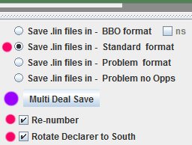
Click Multi Deal Save
This will create (or overwrite) a new file next to your existing lin file called
Lin_Fl__Std.lin
Again, select all the lin files and drag and drop them on aaBridge so you can see all their names in the aaBridge grey left hand column. Compare the two created lin files by how they appear in aaBridge. you will see that the only difference is that the Std Format has the bumps in the navbar numbered 1 and 2 whereas they are o1 and o2 in the BBO format .lin.
If you try, you will discover that you can, by repeatedly saving, change between BBO and Standard format and still preserve all the information in the two deals.
BBO upload format requires that all of one deal is on one line. The older Standard format has extra ‘new-line’ characters in the text which is easier for humans to read.
<end of page>
Problem format
When making ‘problem’ lin files it is simpler to work with deals that have the declarer rotated to South and are in Standard format.
Starting with the previously created file Lin_Fl__Std.lin
Copy it and
Rename the copy to Quiz.lin
Drag and Drop Quiz.lin on to an open aaBridge window.
At this point Quiz.lin has declarer rotated to south and hand renumbered from 1.
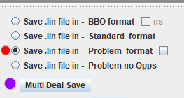
Select Problem format (red dot)
Click Multi Deal Save
In the folder containing Quiz.lin there will now be a second file called Quiz_Prob.lin
Drag and Drop both files on to an open aaBridge window.
Play through Quiz_Prob.lin in aaBridge.
Try solving the two problems YES - Try the problem out.
You will see that problem format has added a front page that tells the user how to use aaBridge to view the problems. Sections like the hand, the bidding, …
have been added and both the deals could do with some introductory text and possibly a commentary on the solution.
In general, ‘the problem format’ works reasonably well for Deal 1, whereas Deal 2, asks us to “think” immediately after the opening lead, and before the opps have finished taking their top tricks. It leaves the reader unsure what Opps final lead will be, so creating unneeded complications in the reader’s mind.
But even so, deals like #1 could be sent to students or any others who use aaBridge for study and thought.
Problem format adding Intro, Comment and Fixes
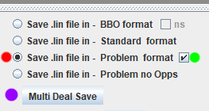
With both files Quiz.lin and Quiz_prob.lin in aaBridge …
Make sure you are viewing Quiz.lin
Select Problem format (red dot)
Check the un-named checkbox (green dot)
Click Multi Deal Save
The Quiz_Prob.lin file will instantly be overwritten and when you view it in aaBridge (just click on it, in aaBridge’s left hand column) you will see that there are now visible ‘Introduction’ and ‘Comment’ text pages, such as…
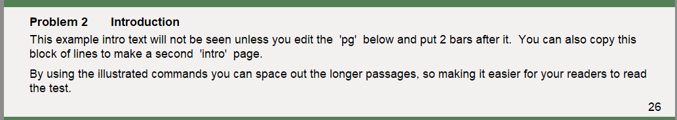
You could open Quiz_Prob.lin file in your TEXT only editor (not a word processor) and edit the text of the “introduction” page to match each particular problem.
However , before we do that we need to work on Problem 2. That is best done by starting with file Quiz.lin which is the (standard format) source file from which we made the ‘problem format’ file.
(this is a one page aside - just here for your information)
How aaBridge 'sees' a lin file
The way aaBridge (and all lin file playing programs) understand lin files is not what you might expect. Below is a shortened version of a lin file
All stuff before any command is ALWAYS skipped overqx|9|pn|GG_Bridge,W,RogerPfi,E|rh| |ah|Board 9 Short Version|md|3sKJT653dA987cAJT,s7hKQ9872dQ64c975,hAT653dKJ532cQ83,sAQ9842hJ4dTcK642|this skipped over as wellsv |n|sk| |pg| |mb|p|mb|2S|an|Weak 2|mb|p|mb|p|mb|p|pg| |pc|s3|pg| |also skippedpc|s7|pc|d3|pc|s8|pg| |mc|5|pg| |
aaBridge works by looking for a two-letter command. It does this by searching for a bar character '|' and then looks at the two characters that come immediately before that '|'. The first command in the above example are the letters qx which come just in front of the first bar, ie: the end pair of what looks like the 'word' - overqx.
The red shows where aaBridge is hunting for a command letter pair and the blue shows text that is then treated as data for that (just found) command. When aaBridge finds the next bar character '|' it knows that the data for that command has ended and it goes back to hunting for yet another bar which will define the next command letter pair.
Some commands like rh|| (remove header, on the second line) have no data hence the need for two bar characters next to each other.
New lines and spaces play no part when hunting for the next command
Notice that spaces and new lines play NO PART in the cmd|data|cmd|data|cmd|data pattern. When processing a lin file, aaBridge treats them as any other character. If looking for a command they are ignored and when sucking up data they are 'given' to the command as part of its data.
When using Problem format - Pick a good (free) text editor
read the doc collection docs
Mac and Win - Working with Text Files.doc
(for windows) Notepad++ How to setup for Windows.doc
<the main text continues on the next page>
Problem format adding Intro, Comment and Fixes (continued)
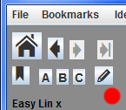
Open Quiz.lin in your TEXT only editor,
If you have an editor that aaBridge can detect (e.g. Notepad++) the pencil icon (red dot) will open the file in your editor for you.

Note that when you are “Inside a Deal”, as is the case when Standard Format files (like Quiz.lin) are being displayed by aaBridge you may need to click the Back to Movie button (bottom right in aaBridge). After that the pencil icon will show as enabled.
Board 1
In your editor some of Board 1 (roughly lines 7 to 18) should closely resemble
...
mb|1H|mb|p|mb|2N!|an|4 @h's 12+|mb|p|mb|3C!|an|cue|mb|...
pc|s9|pg||
pc|sA|pc|s5|pc|s6|pg||
pc|hA|pc|s2|pc|h2|pc|h6|pg||
pc|h5|pc|c2|pc|hK|pc|h7|pg||
pc|h3|pc|h8|pc|hQ|pc|d2|pg||
pc|sQ|pc|sK|pc|h4|pc|s8|pg||
pc|d5|pc|d4|pc|dK|pc|d3|pg||
pc|sJ|pc|s4|pc|c6|pc|d7|pg||
pc|sT|pc|c3|pc|d6|pc|hJ|pg|| (pc = play card)
pc|dQ|pg||
mc|12|pg||

Delete all the lines AFTER the opening lead 's9' so it now looks like this.
...
mb|1H|mb|p|mb|2N!|an|4 @h's 12+|mb|p|mb|3C!|an|cue|mb|...
pc|s9|pg||
(you are still looking at Quiz.lin in your text editor)
Board 2
Scroll down to Board 2 which starts something like …
qx|2|pn|will_be_South, will_be_West, will_be_North, will_be_East|
rh||ah|Board 2 |
md|2s43hAKQ87dQT ...
Do two things,
a) Delete the last 4 lines of play so the last card played is the cQ pc|cQ|pg||
b) Add eb|y___| just after the play of the h5 pc|h5|
so it looks like this

mb|1S|mb|p|mb|p|mb|d|mb|2S|mb|2N|mb|p|mb|3H|mb|p|mb|4H|mb|p|mb|p|mb|p|pg||
pc|sA|pg||
pc|sT|pc|s9|pc|s3|pg||
pc|sK|pc|sJ|pc|s2|pc|s4|pg||
pc|s5|pc|sQ|pc|h5|eb|y___|pc|h7|pg||
pc|hA|pc|h4|pc|h9|pc|h2|pg||
pc|hK|pc|h6|pc|hT|pc|h3|pg||
pc|dQ|pc|d8|pc|dJ|pc|d2|pg||
pc|d5|pc|d9|pc|dK|pc|d3|pg||
pc|dA|pc|d4|pc|dT|pc|s6|pg||
pc|c2|pc|c3|pc|cT|pc|cQ|pg||
-- last 4 lines deleted --

Save the above changes to Quiz.lin from inside your editor.
as before, with both files Quiz.lin and Quiz_Prob.lin in aaBridge …
Make sure you are viewing Quiz.lin
Select Problem format (red dot)
Check the un-named checkbox (green dot)
Click Multi Deal Save
<continued on next page>
With the click on Multi Deal Save the Quiz_Prob.lin file is immediately overwritten. When you view it in aaBridge (just click on it, in aaBridge’s left hand column) you will see that both problems still have the new added ‘Introduction’ and ‘Comment’ text pages, such as…
Play through the new Quiz_Prob.lin
Problem 1 is short and to the point and would even be interesting without the ‘Introduction’ or ‘Comment’ text pages.
Problem 2 now has an ‘Early play’ page which stops at a sensible point where the reader is asked to do their thinking.
Note – that boilerplate text for the ‘Introduction’ and ‘Comment’ pages is always included in problem format deals. Creating a Problem deal with the (green dot) checkbox checked only makes them visible. Hiding or deleting these pages is covered in the next section.
Multiple or Single ?
While it makes sense to use Multi Deal Save to quickly transform a collection of deals into a lin file containing ‘simple problems’, it makes more sense to have a single file which grows as you add newly created problems.
To illustrate this the next section covers adding a new problem (actually a duplicate of problem 2) to our previously created Quiz_Prob.lin file.
In addition, we will see that working with a single deal means we can get aaBridge to insert the eb|y___| without us having to do the editing.
Working with Problem format on just a single deal
Here we will just work on a single deal. Start with the Standard format file you created earlier called Lin_Fl__Std.lin
(If you no longer have it, repeat the early instructions to recreate it.)
Copy it and
Rename the copy to Prob2.lin
Look at the new file in your editor Scroll down to problem 2 which starts like …
qx|2|pn|will_be_South,will_be_West,will_be_North,will_be_East|
rh||ah|Board 2 |
md|2s43hAKQ87dQT ...

Delete all of Problem 1 so that the first line shown above is the first line of the file. and Save the file. This file Prob2.lin is the main file we will work with.

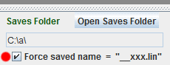
In aaBridge raise the lower (bottom) divider bar and
Check the Force saved name = " … checkbox
Click the Open Saves Folder button
Your ‘Saves’ folder should now show.
If there is nothing of importance (to you) in the ‘Saves’ folder it will help if you delete any files that are in it. If you have not done any ‘Saves’ before there won’t be any files in the Saves folder.
<continued on next page>

Move e.g. using Drag and Drop Prob2.lin into the ‘Saves’ folder.
Drag and Drop Prob2.lin on to an open aaBridge window.
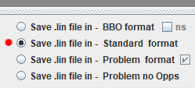
Select Standard format (red dot)

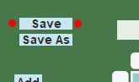
While viewing the Prob2.lin file in aaBridge you should see in the top left hand corner the Save button (red dots).
If you do not see the button you may need to click the
Back to Movie button, bottom right in aaBridge.
Click the Save button (NOT the Multi Deal Save)
In the Saves folder you should now see 2 files __xxx.lin and Prob2.lin
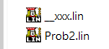
Drag and Drop both files on to the open aaBridge window
Play through __xxx.lin in aaBridge
View __xxx.lin in your editor
Unsurprisingly, the file __xxx.lin is a duplicate of Prob2.lin
<continued on next page>
Getting aaBridge to add the eb|y___|
View Prob2.lin in aaBridge.

Play through the file, the Save button will be visible. If it is not, use the
Enter the Deal button.
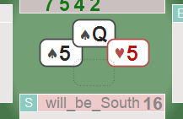
Have __xxx.lin viewing in your editor.
Play through Prob2.lin in aaBridge
(use Flow and > single arrow) until you get to the point in the play shown on the right.
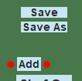
(You could even add your own ‘Early Play’ if there was none.)
Click the Add button (red dots) ‘Add’ will then say ‘Rem’.
Click the Save button.
View __xxx.lin in your editor.
You will see the eb|y___| has been inserted in to the correct place in the play.
pc|sT|pc|s9|pc|s3|pg||
pc|sK|pc|sJ|pc|s2|pc|s4|pg||
pc|s5|pc|sQ|pc|h5|eb|y___|pc|h7|pg||
pc|hA|pc|h4|pc|h9|pc|h2|pg||
It is best to think of the __xxx.lin file as a temporary place continually being overwritten by the Saves button. At this point it makes sense to copy what you want out of the __xxx.lin file and put it into Prob2.lin. So using your editor.
Copy the contents of __xxx.lin and put it into Prob2.lin
At this point you can also make any other changes such as deleting the last four lines of play.
Delete the last 4 lines of play so the last card played is the cQ pc|cQ|pg||
<continued on next page>
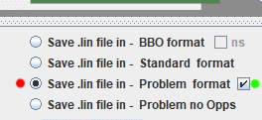
Problem format with a single deal

Select Problem format (red dot)
Check the un-named checkbox (green dot)

View the replaced / edited Prob2.lin in aaBridge
Click Enter the Deal if you need to.
Click the Save button.
View __xxx.lin in your editor.
The __xxx.lin file will now contain the problem format additions such as the play follows page shown below.
ht|m|at|^e Play follows ...|
bv|f,v|
pf|first-button|
pg||
Again, I now recommend copying the contents of the __xxx.lin file to somewhere more secure. This is because the will be overwritten every time the Save button is pressed.
Copy the contents of __xxx.lin and put it into Prob2.lin
From this point on their is no further use of the aaBridge Save or Multi Deal Save buttons to make changes to files. You will just use your standard text editor to make the final changes.
The natural thing to do, when the Prob2.lin file is complete, would be to copy it to the Quiz.lin which represents a growing collection of your Bridge Problem deals.
<continued on next page>
Final edits to a Problem format lin file
At this point you have a problem format lin file called Prob2.lin which has a single deal in it. The ‘ask’ point in the desired place and the ‘Introduction’ and ‘Comment’ pages are visible but still contain the original boilerplate text.
View your file Prob2.lin in aaBridge and also have it
Open in your text editor. Whenever you save the file, aaBridge will update its display to show you what a reader would see.
Locate the boilerplate text for the ‘Introduction’ it should look something like
at|^*b Introduction^*n|
lg|c|n#|3|
at|^^ ...
... |
pg||

You could change it to read something like
at|^*b Introduction^*n|
lg|c|n#|3|
at|^^With two top @s losers already taken you can only afford one more. The repeated finesse in @c's looks a good option, it makes 75% of the time. It only loses when West has both the King and Queen of @c's.|
n#|5|at|^^Can you improve on these odds ? What if the trumps split 2 - 2 ?|
pg||

In a similar way you could change the ‘Comment’ text to read . . .
at|^*b Comment^*n |
lg|c|n#|3|
at|^^If the trumps split 2-2 you can increase the chance of making to 100%. |
n#|5|at|^^Test the trumps, when found to be 2-2, play off all the @d's and lead a low @c from dummy, should East play low put in the @c10. If West has both the @cKQ she will now be endplayed.|
pg||

You could also change the title ‘Comment’ to ‘Solution’. If you so, also make the change on the earlier line that reads.
at| show a ^*b Comment^*n.|

The embedded text for both the ‘Introduction’ and ‘Comment’ are present in every problem format deal. The un-named checkbox (green dot) that you used earlier only has the effect of making their text visible.
The way to make any of the original hidden text visible is described in comments in the problem lin file itself. For example, to hide or show the ‘an intro follows’ text, you would manually edit the two ‘!’ characters that follow the ‘at’ command into ‘|’ (a bar character) as described in the text, also shown below.
%%
%% below, change the two ! to bars show the 'an intro follows' text.
%%
at! an intro follows!

Common Lin File commands
The main reference for Lin file commands is got to via
the aaBridge Help and How do I ? menu entry, towards the end in red is
What goes on inside a .lin file, and that link takes you to a compact one-page index of the lin file two letter commands.
List of common (in problem files) two letter commands and meanings
at|...| Add Text shows the ... text on the page.
n#|5| drop 5 ‘points’ = half a line.
lg|?| Line Gap if ? = a-z are valued as 10–36 ‘points’.
ht|?| go to position between top ? = a and bottom ? = z
pg|| Page a pause point where a user stops and reads.
bv|...| Make the 1st, Cont, and Enter ... hidden / visible.
pf|...| Show a particular message about 1st etc. buttons.

Within an ‘at’ command
^^ New line, start the next line using the line gap.
@s Spade symbol @h = Heart symbol etc.
^? go to position ? = a-z a is Left z = Right
^*b start bold ^*n = end bold (and other stuff).
How a page is cleared within the Problem format
The normal way to clear a page of text in lin files is to use the command
nt||
This is done at the beginning and end of each problem. However during the bulk of text the following command string is used.
ht|e|n^|3|at|^e@5@4^z@3^b@2^^|ht|e|n^|5|at|^e|

It occurs a number of times in every problem format file. It is preferred because it clears all BUT the area in the TOP LEFT where the text Problem 1 is displayed. The means that you the writer need to change the problem number in just 3 places to have it change throughout the entire text (see below).
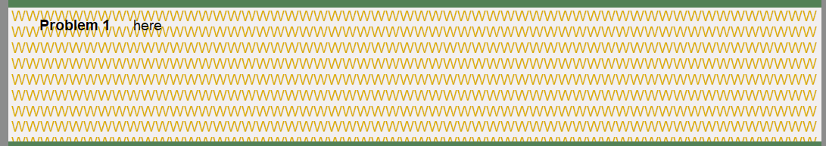
Here the table text area has been filled with light brown W’s. And you can see where the normal heading Problem 1 is written. ‘here’ shows where any new text will go.
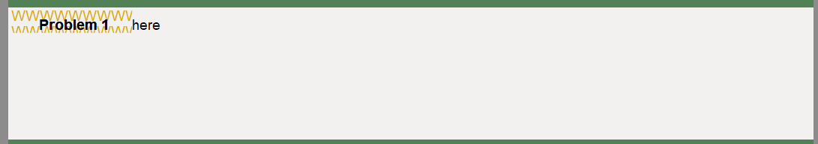
The command string given earlier clears the area shown below. From this you can see the area that you should leave alone and so preserve the title and number.

How to Change the Problem number (and name)
The three places are at the start of each problem…
qx|1|bv|a,h|
rh||ah|Problem 1|
nt|^b@2^^|n^|5|at|^*bProblem 1^*n ^e the hand, |

You can also change the word ‘Problem’ you might prefer - Example or End Play.
What of – Study Mode ?
If you put the two letters ‘zm’ into a lin file header as in ht|zm|, when you then save in Problem Format that deal will be saved in Study Mode which hides a lot of the aaBridge features from the problem solver so they have to think more.
You can remove the ht|zm| text once the problem has been saved.

What of – Problem no Opps ?
A lin file created with Problem no Opps contains no Opps cards. It has any play preserved and the cards are added to the Opps hands as the they are played. This stops a user of the lin file accidently or intentionally seeing the Opps hands – for example by pressing the Power Kib Show all Hands check box.
This as you will see by trying out Problem no Opps starting from a lin file called
File.lin
It will create a file named
File__Prb-nop.lin
Shuf Op button
Even if a user only has the opening lead available and NO other given opps cards, they can generate Opps hands using the Shuf Op button.
Note that the early play / opening lead is preserved.
This way users can play the deal against many different layouts of the Opps hands.
See the aaBridge YouTube Video
008 Using ‘Shuf Op’ and the Analyser in aaBridge
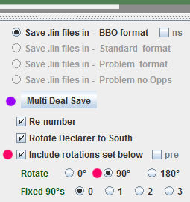
What of – Include rotations ?
These settings are there for use by Teachers and others.
Suppose a teacher has a set of files which illustrate a particular point of declarer play. The settings on the right will take her lin file with all the deals in it and will produce a finished lin file where each seat around the table gets to be declarer in order.
This way the teacher needs only keep one master file and can rotate is before uploading to BBO.
Fixed 90's are used to select the first seat to be declarer. Selecting '1' would make West (not South) be the first declarer.
See the doc collection document
Making Deal Sets for BBO Tournaments .doc
Help and How do I ?
For more on eb y Look in the aaBridge Help and How do I menu entry, towards the end in red is - What goes on inside a .lin file
Go into that lin file and on the LEFT hand side (below half way) is the entry
eb mx kc E Blocker, Keep cards
Click on the blue eb mx kc (you will be taken to the E Blocker lin file)
Near the left of the Navbar is the entry for eb y later you will see ebY+

<end of document>

